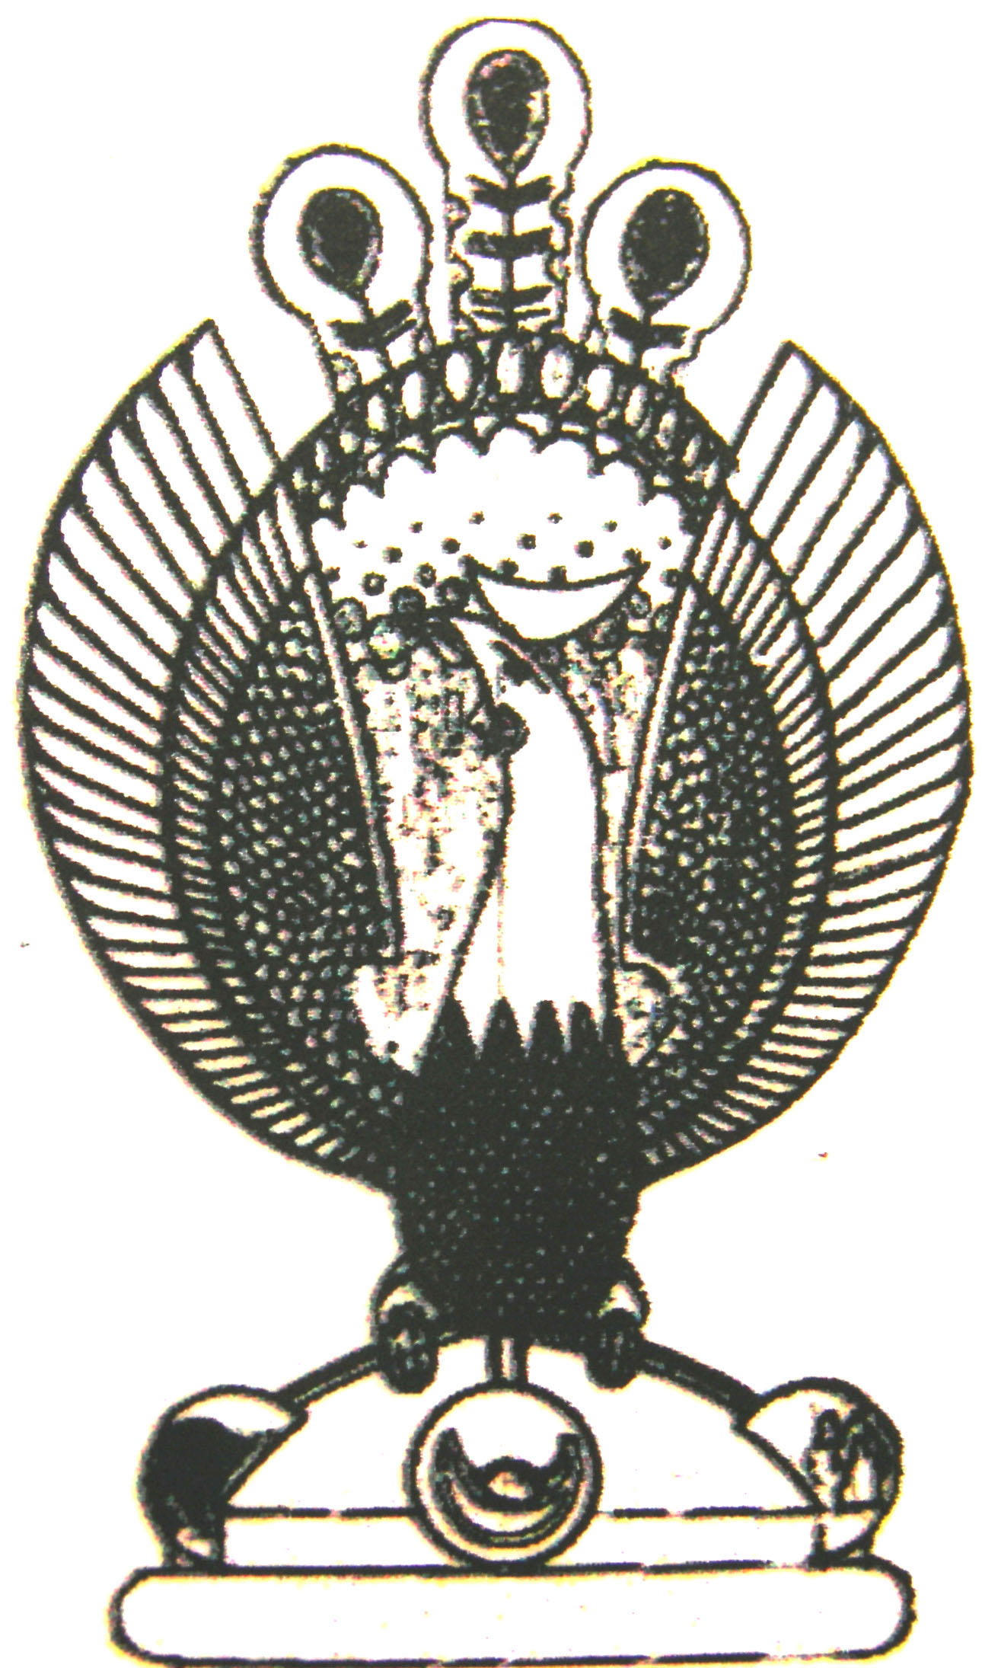

THE HERITAGE

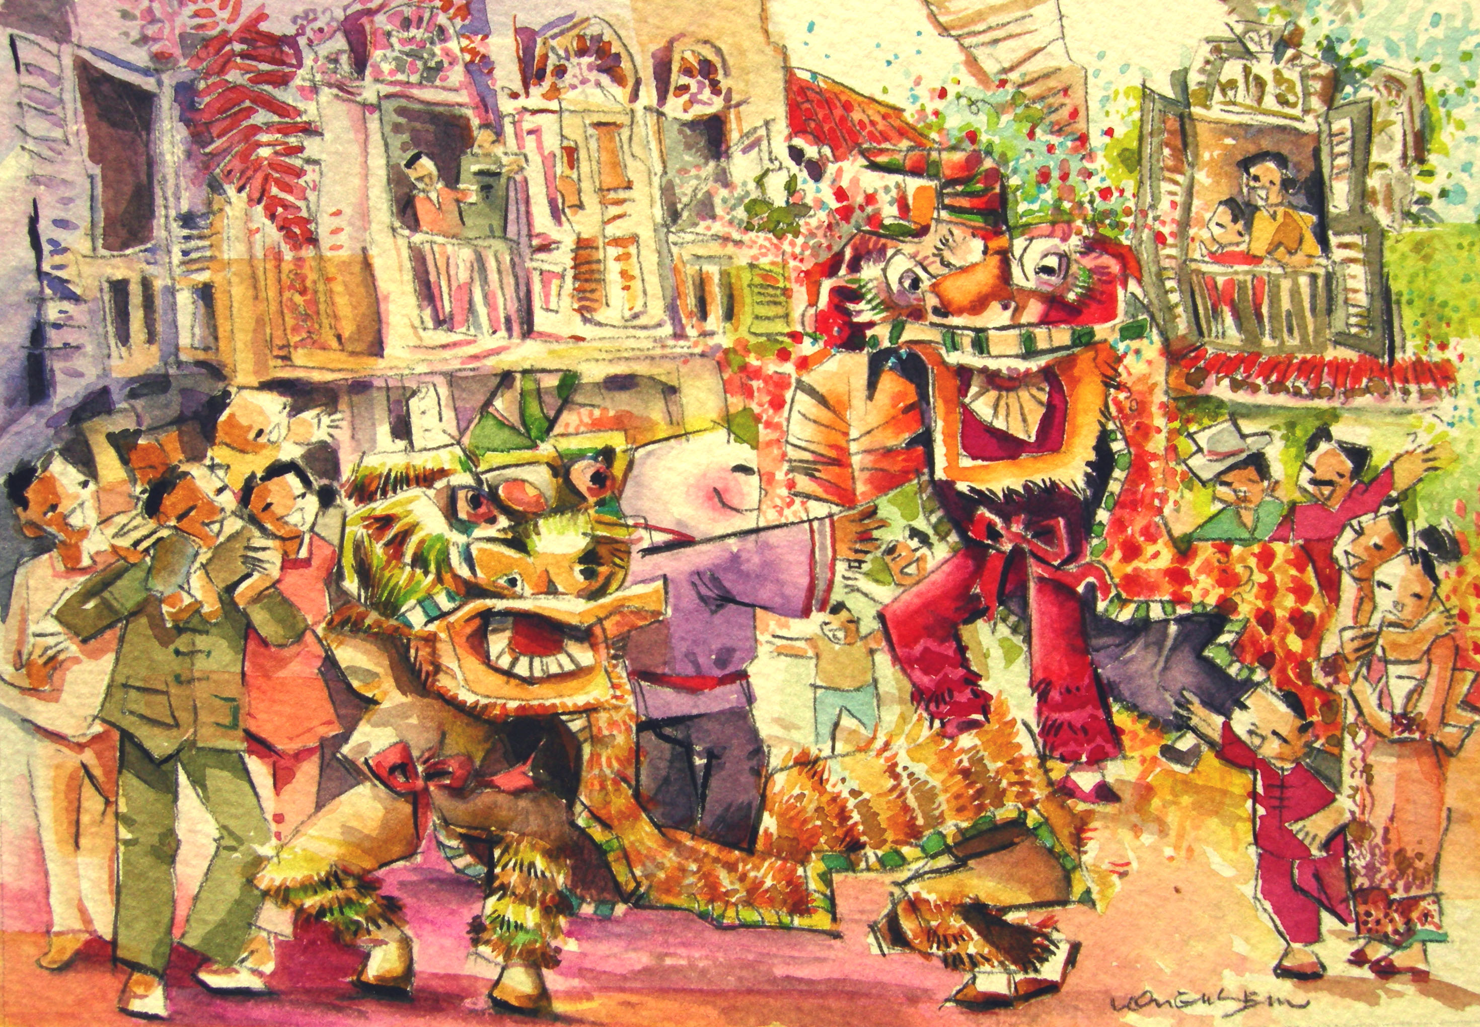
Chinese New Year
Chinese New Year. Like the Chinese, the Peranakans regard the Chinese New Year as the most important festival of the year.

